Argument:

For P21.

Maybe this answer is not same to the professor’s or your answer, that doesn’t mean it is a wrong answer.

I use 8-bit sequence nunmber to construct the FSM. And I think my FSM work well. Maybe I don’t have drown four states here, but pleases notice that I have a “current_sequence” variable here. It just has the same function with your four states.

P21.

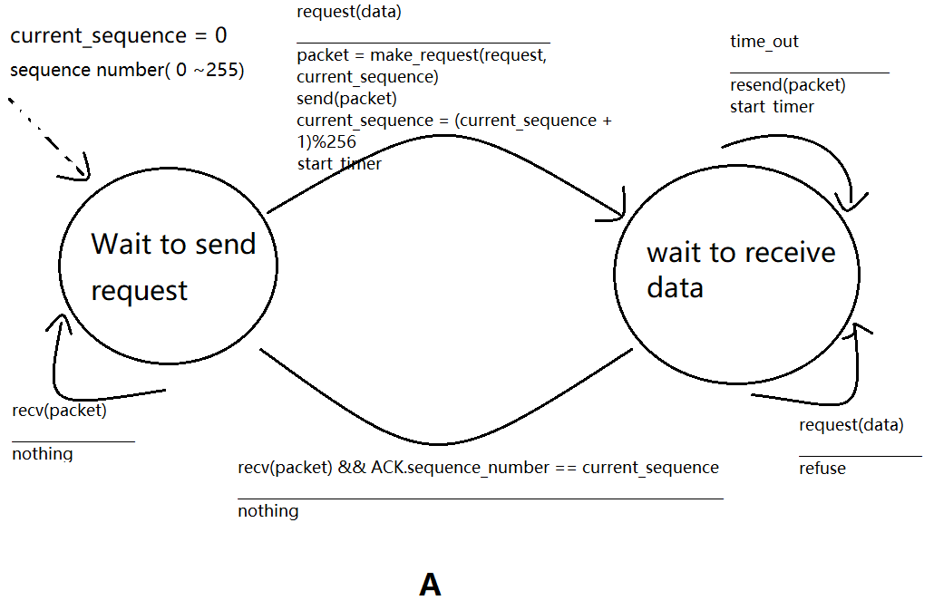

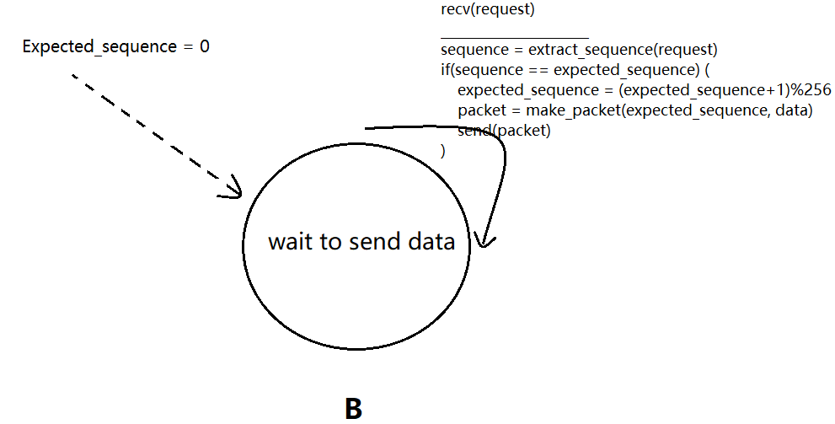

P.27

a. Sequence number:207

source port number: 302

destination port number:80

b: acknowledgment number:207

source port number:80

destination port number:302

c. acknowledge number:127

d.

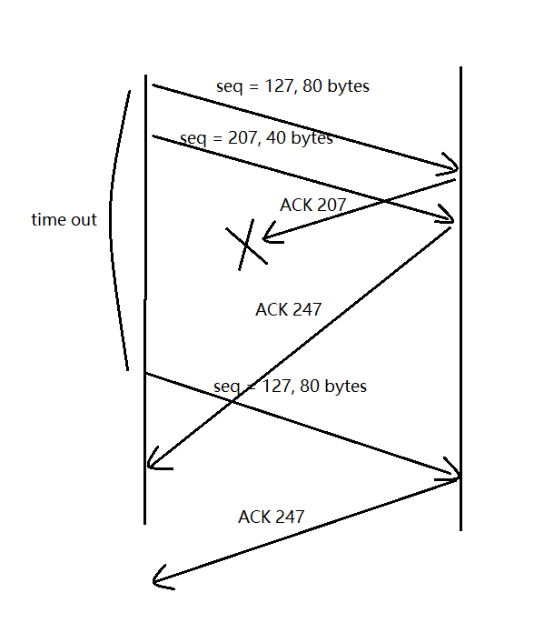

P.44

a. There is no slow start and loss events, let’s assume this connection is in Avoid Congestion state.

The cwnd increase 1 MSS over one RTT, such that the total time = (12MSS-6MSS)/1(MSS/RTT) = 6 RTT

b. 1 RTT -----1 MSS

2 RTT ------2 MSS

3 RTT ----- 4 MSS

…..

6RTT ------32 MSS

Such that the average throughout = (2^0 + 2^1 +…+2^5) MSS / 6 RTT = 10.5* MSS/RTT